Installation ASP.NET CORE 8.0

Pre-requisities:

Download link: <https://dotnet.microsoft.com/en-us/download/dotnet/8.0>

1. .NET 8.0 (LTS) --- Long Term Support (windows x64)
2. Visual Studio 2022(v17.11)

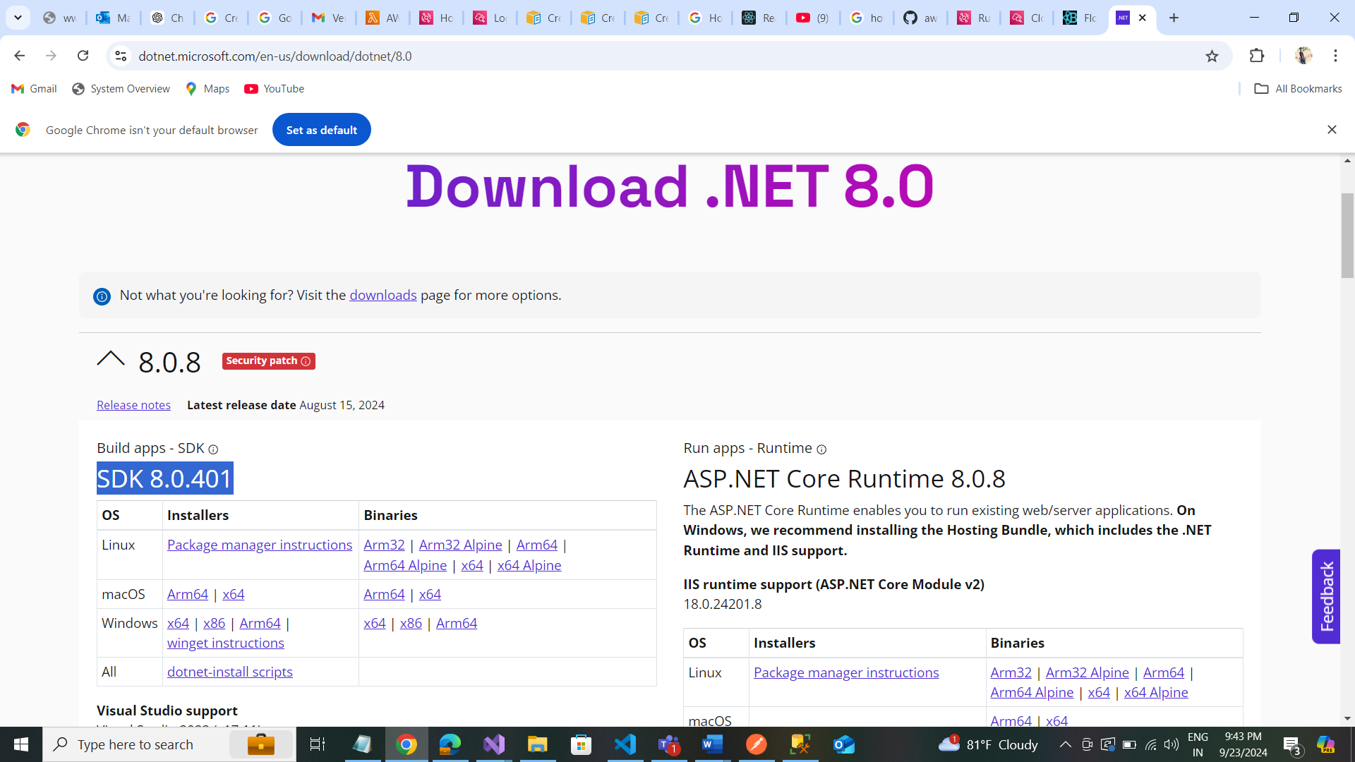

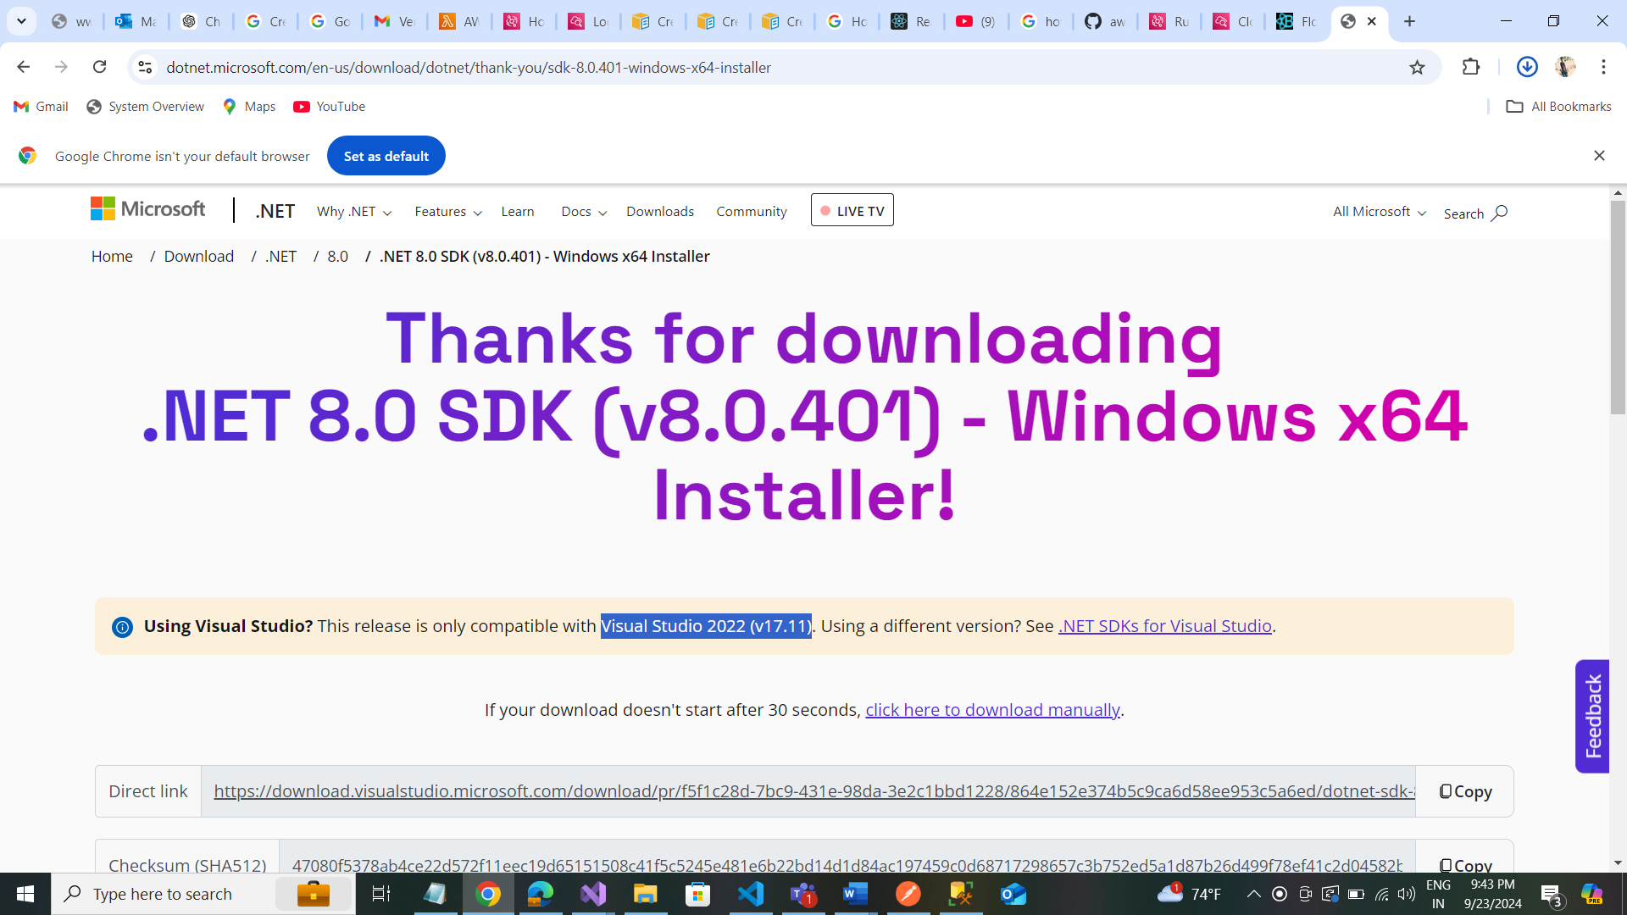

Update Visual Studio: Update Visual studio by clicking Update button.

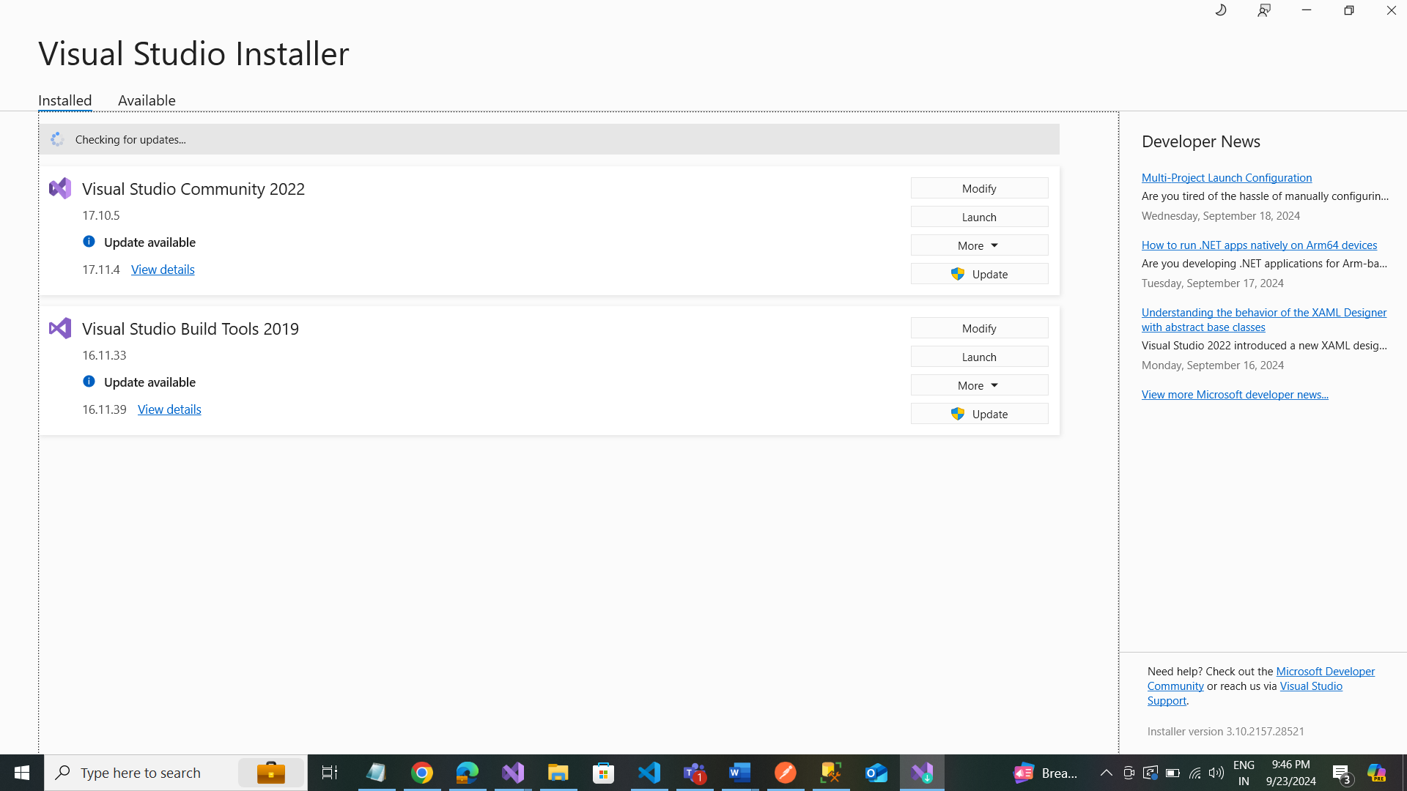

Using visual studio: Update with visual studio 2022

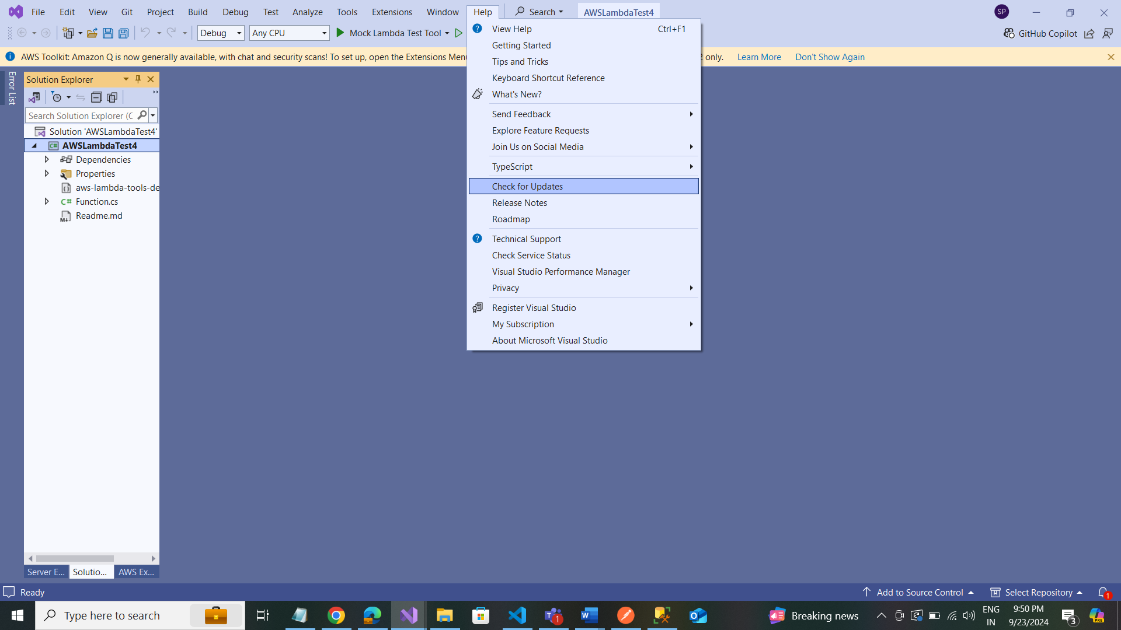

Create .NET 8.0 Project:

